**Testing and Linting Results**

1. **Testing results**

Using pytest, a total of 7 unit tests were written to test the basic functionality of the application. Testing results are presented below:

1. **Linting results**

The code was linted using pylint and as many warnings were silenced as possible. Some warnings could not be silenced due to the nature of packages used throughout the application.

After running pylint for the first time, the code was refactored many times to enhance the code elegance. The results and the increased pylint score show that this goal has been achieved.

The pylint results before after refactoring the code can be found below:

* 1. **Results before refactoring**

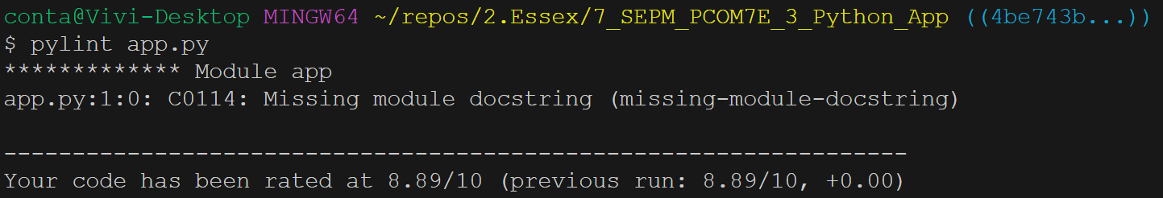

* 1. **Results after refactoring**

